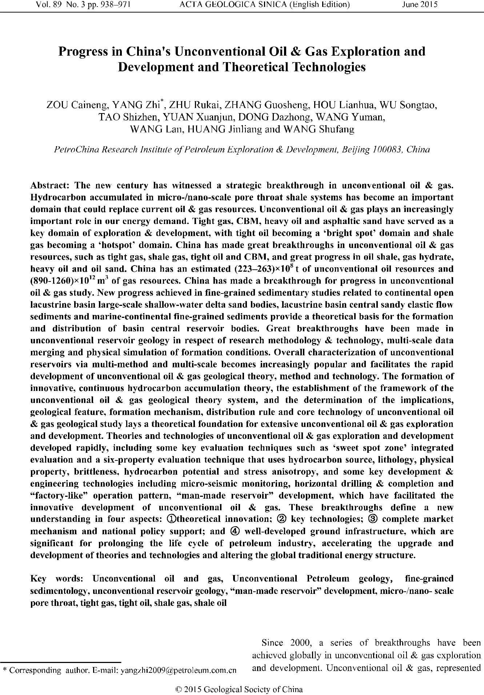

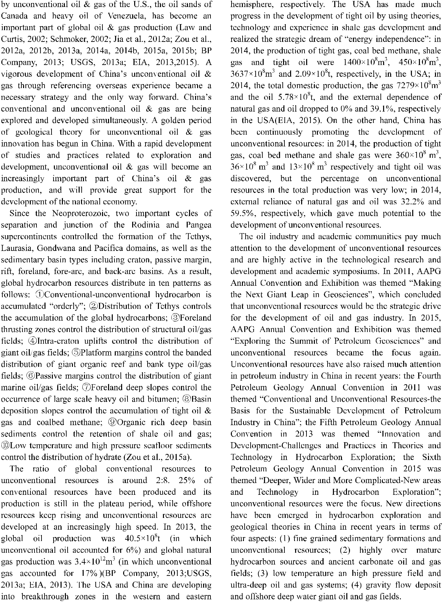

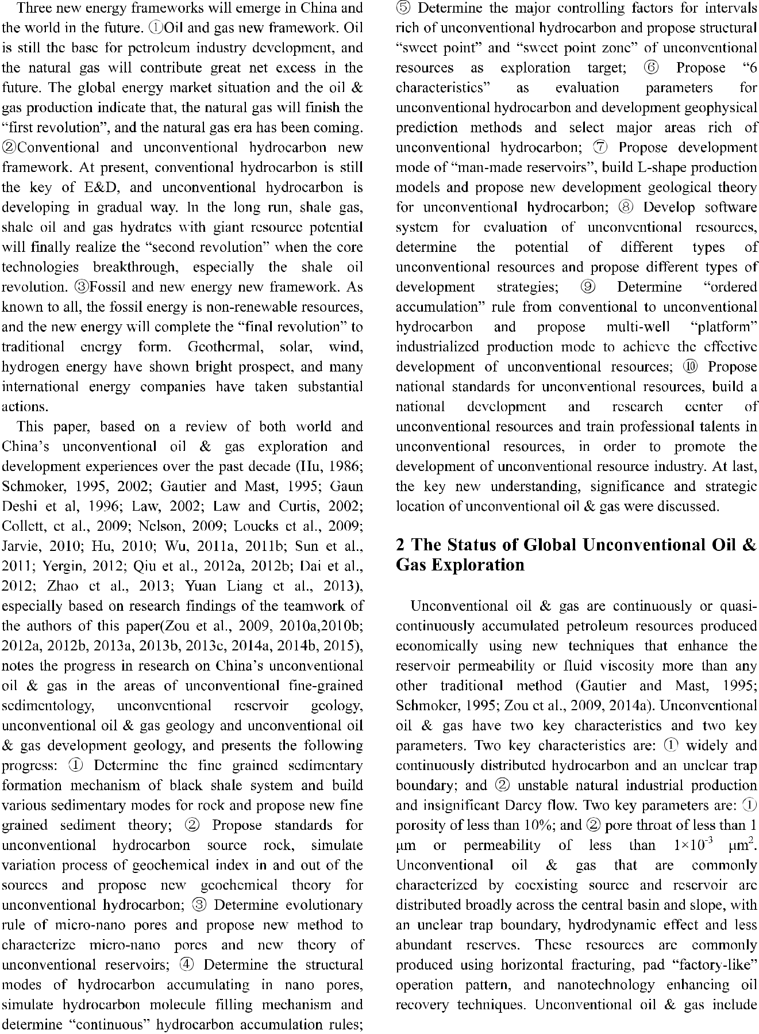

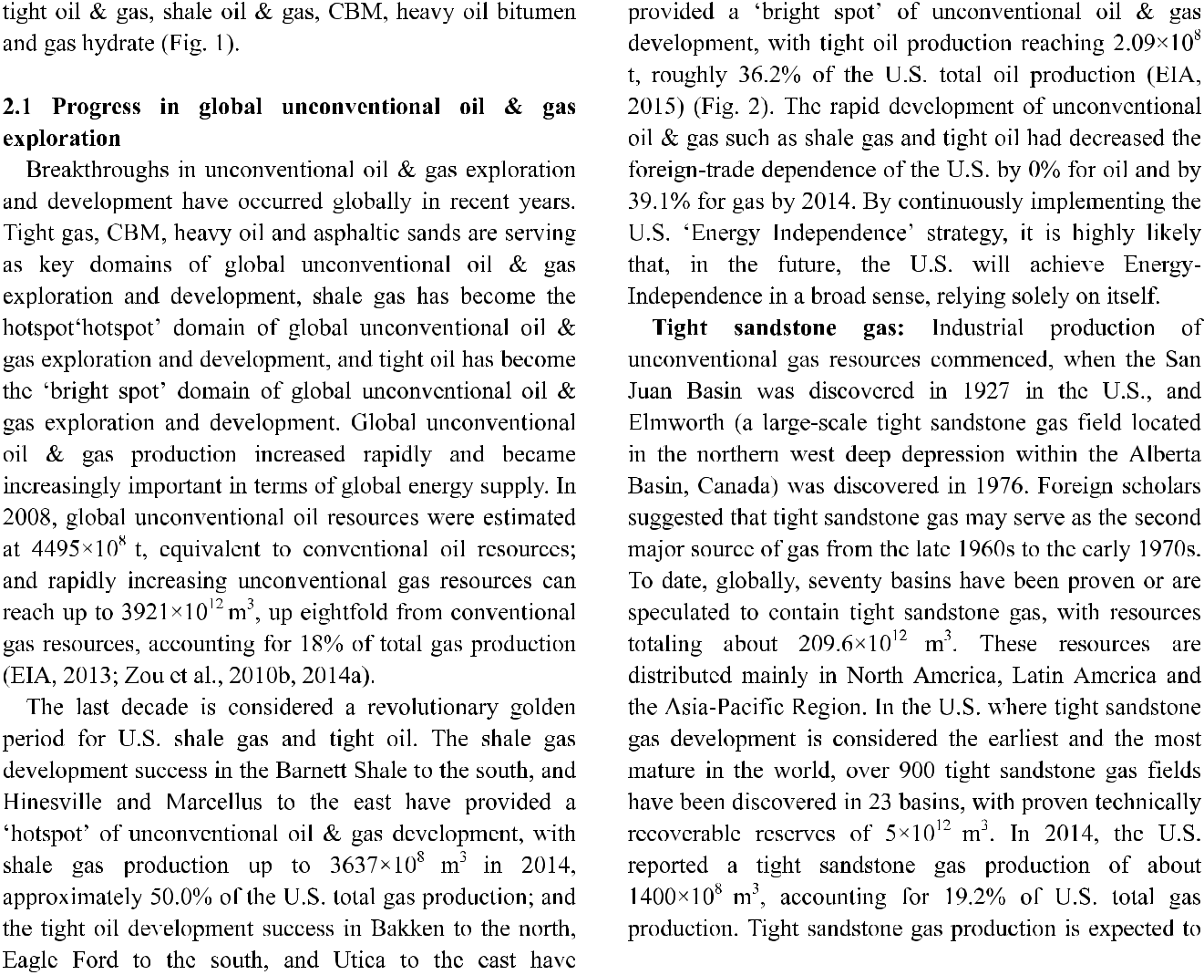

Conventional hydrocarbons

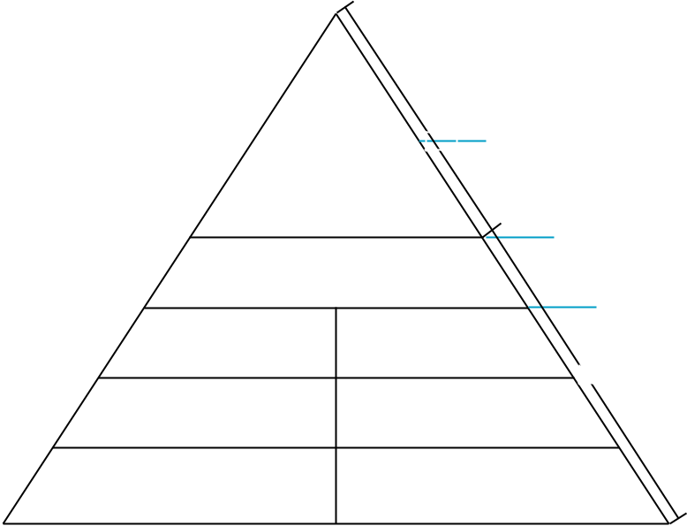

|  |  |  |  |  |
| --- | --- | --- | --- | --- |
|  | 1850 |  |  |  |
|  | Single | | |  |
|  | Structural | | |  |
|  | oil and gas | | |  |
| 1920 |  |  | |  |
|  |  | 20 |  |
|  |  |

stage

(year)

1980

Lithologic

stratigraphic oil and gas

Cluster

Resource

Industrial

2010

Heavy oil+tar sand+carbonate

(volcanic) fracture-cavern oil and gas

|  |  |  |
| --- | --- | --- |
| Tight oil | Tight gas+coal- |  |
| bed methane |  |
|  |  |

percentage

Quasi-continuous

(%)

80

|  |  |
| --- | --- |
| Shale oil | Shale gas |
| 2030 |  |
| Oil shale | Gas hydrate |

2150

Unconventional oil



Continuous

Unconventional gas



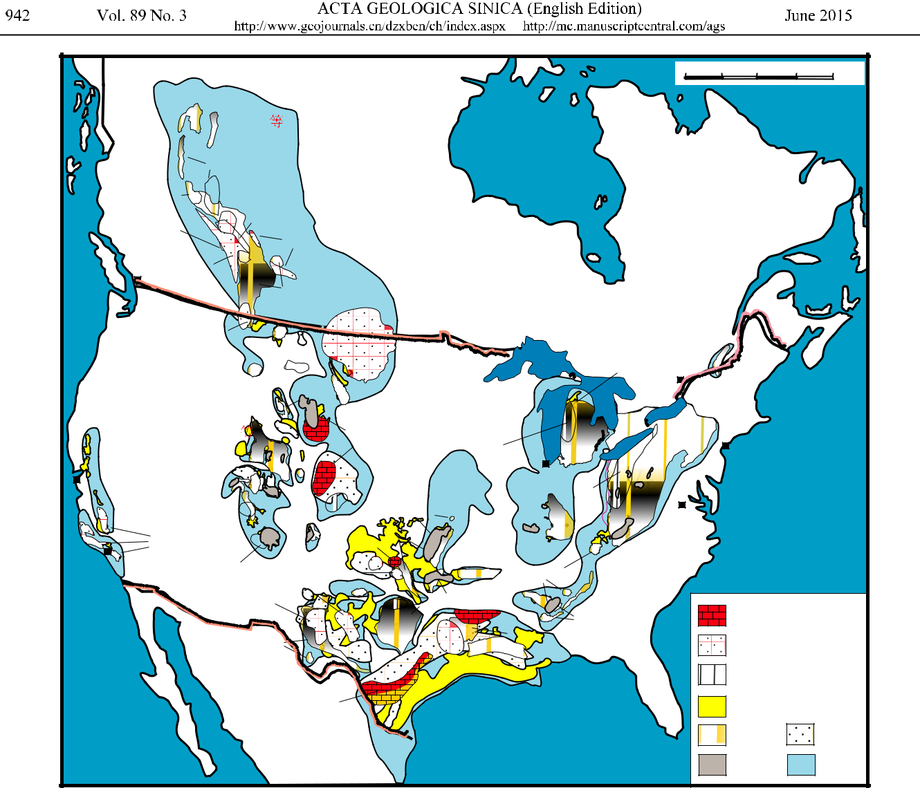

|  |  |  |  |  |  |  |  |  |  |  |  |  |  |  |  |  |  |  |
| --- | --- | --- | --- | --- | --- | --- | --- | --- | --- | --- | --- | --- | --- | --- | --- | --- | --- | --- |
|  |  |  |  |  |  |  |  |  |  |  |  |  | 0 | 250 | 500 | 750 | 1000 km |  |
|  |  |  | Muskwa | |  |  |  |  |  |  |  |  |  |  |  |  |  |  |
|  |  |  | Montney |  |  |  |  |  |  |  |  |  |  |  |  |  |  |  |
|  | Doig Phosphate | |  |  |  |  |  |  |  |  |  |  |  |  |  |  |  |  |
|  |  | Banff | Duvernay | | |  |  |  |  |  |  |  |  |  |  |  |  |  |
|  |  |  |  | Viking |  |  |  |  |  |  |  |  |  |  |  |  |  |
|  |  |  |  |  |  |  |  |  |  |  |  |  |  |  |  |  |  |
|  |  | Cardium |  |  |  |  |  | Canada |  |  |  |  |  |  |  |  |  |  |
|  |  | Vancouver |  |  |  |  |  |  |  |  |  |  |  |  |  |  |  |
|  |  |  |  |  |  |  |  |  |  |  |  |  |  |  |  |  |  |
|  |  |  |  | Colorado | |  |  |  |  |  |  |  |  |  |  |  |  |  |
|  |  |  |  | Niobrara | |  |  |  |  |  |  |  |  |  |  |  |  |  |
|  | Bakken/Exshaw | | |  |  |  |  |  |  |  |  |  | Utica | |  |  |  |  |
|  |  | Mountains |  |  | Heath |  |  |  |  |  |  |  |  |  |  |  |
|  |  |  |  |  | Bakken | |  |  |  | Antrim |  |  |  |  |  |  |
|  |  |  |  |  |  |  |  |  | Ottawa |  |  |  |  |  |
|  |  | Cody |  |  |  |  |  |  |  |  |  |  |  |  |  |  |
|  |  |  |  |  |  |  |  |  |  |  |  |  |  |  |  |  |
|  |  |  |  | Mowry | |  |  |  |  |  |  |  |  |  |  |  |  |
|  |  |  |  |  | Gammon | |  |  |  |  |  |  |  |  |  |  |  |
|  |  |  |  |  |  | USA |  |  |  |  |  |  |  |  |  |  |
|  | Rocky |  |  |  |  |  |  |  |  |  |  |  |  |  |  |  |  |
|  | Hilliard | |  |  | Niobrara | | Collingwood | |  |  |  |  | New York | |  |  |  |
|  |  |  |  |  |  |  |  |  |  |  |  |
|  |  |  |  |  |  |  |  |  |  |  |  |  |  |
|  |  |  |  |  |  |  |  |  |  |  |  | Mountains |  |  |  |  |  |
| San Francisco | | | Mancos |  |  |  |  |  |  | Chicago | |  |  |  |  |  |  |
|  |  |  | Cherokee Atoka | | |  |  |  |  |  |  |  |
|  |  |  |  |  |  |  |  |  |  |  |  |
|  |  |  |  |  |  |  |  | Utica | |  | Atlantic | |  |  |
|  |  |  |  | Hermosa | |  |  |  |  |  |  |  |  |
|  |  | Wasatch | |  | Excello-Mulky | |  |  |  |  |  |  |  |  |
|  |  |  |  |  |  |  | Washington | |  |  |  |  |
|  |  |  |  |  | New Albany | |  |  |  |  |  |  |
|  |  |  |  | Lewis | |  |  |  |  |  |  |  |  |  |
|  |  |  |  | Pierre | Woodford | |  |  |  |  |  |  |  |  |
|  |  | Monterey |  |  |  |  | Appalachian | Marcellus |  |  |  |  |  |
|  |  |  |  |  |  |  |  |  |  |  |  |  |
|  |  |  |  |  | Mississipian | |  |  |  |  |  |  |  |  |  |
|  |  |  |  |  |  |  |  |  |  | -Utica |  |  |  |  |  |
|  |  |  |  |  | Cleveland | | |  | Fayetteville | |  |  |  |  |  |  |
| Los Angeles | | |  |  |  |  |  |  |  |  |  |  |
| Cane Creek | | Granite Wash | | |  |  |  |  |  |  |  |  |
|  |  | Chattanooga | |  |  |  |  |  |  |
|  |  |  |  |  |  |  |  |  |  |  |
|  |  |  |  |  | Straberry | | Bend |  |  |  |  |  |  |  |  |  |  |
|  |  |  |  |  |  | New Caney |  |  |  |  |  |  |  |  |  |
|  |  |  | Bone Spring | | |  |  |  |  | Conasauga | |  |  |  |  |  |
|  |  |  |  |  |  |  |  |  |  |  |  |  |
|  |  |  |  |  |  |  |  | BarnettBrown Dense | | | Floyd-Neal | |  | Tight carbonate oil | | | |  |
|  |  |  |  |  |  |  |  |  |  |  |  |  |
|  |  |  | Barnett- | | |  |  |  | Haynesville-Bossier | | | |  | Tight sandstone oil | | | |  |
|  |  |  |  |  |  |  |  |  |  |  |  |
|  |  |  | Woodford | | |  |  |  |  |  |  |  |  |  |
|  |  |  |  |  | Woodbine Tuscaloosa | | |  |  |  |  |  |  |  |  |
|  |  |  |  |  |  |  |  |  |  |  | Shale condensate oil | | | |  |
|  |  |  |  |  |  |  |  |  |  |  |  |  |  |  |
|  |  |  |  |  | Eagle Ford | |  |  |  |  |  |  |  | Conventional gas | | | |  |
| Pacific |  |  |  |  |  |  |  |  |  |  |  |  |  |  |
|  |  |  | Mexico | |  |  |  |  |  |  |  |  | Shale gas | |  | Tight gas |  |
|  |  |  |  |  |  |  |  |  |  |  |  |  |  |  |  |  |  |
|  |  |  |  |  |  |  |  |  |  |  |  |  |  |  | CBM |  | Basin |  |

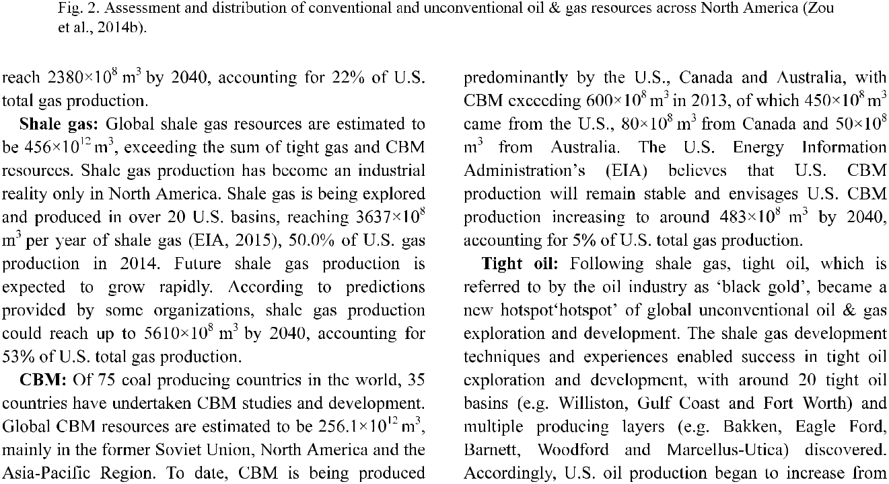

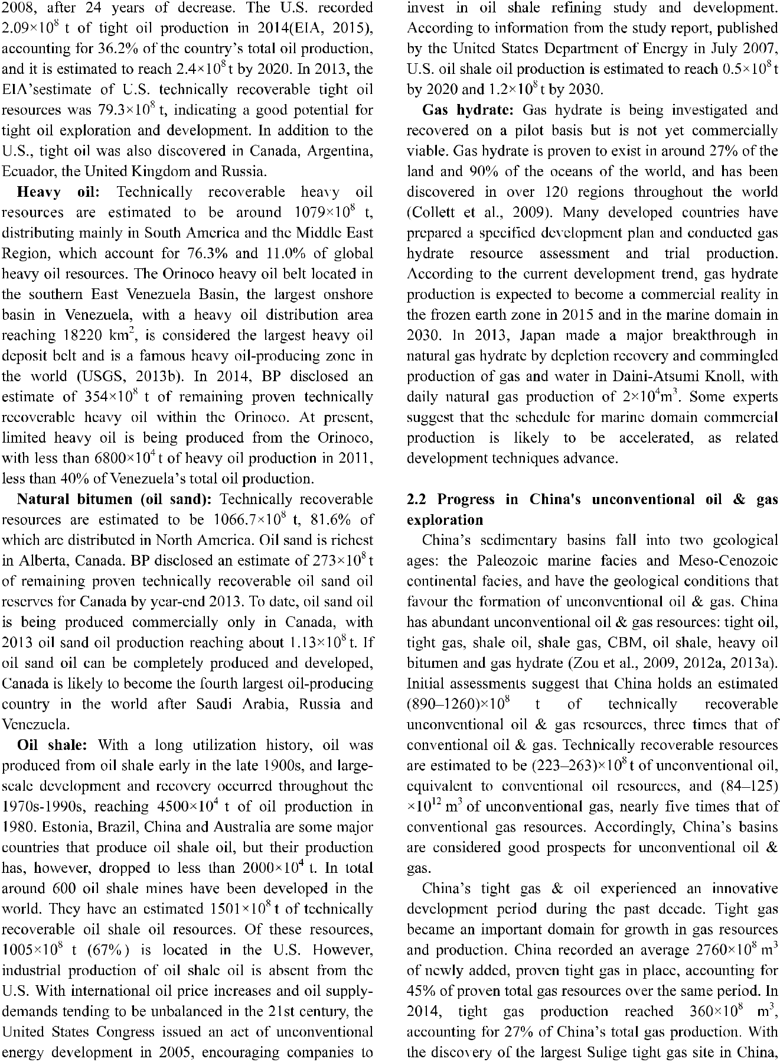

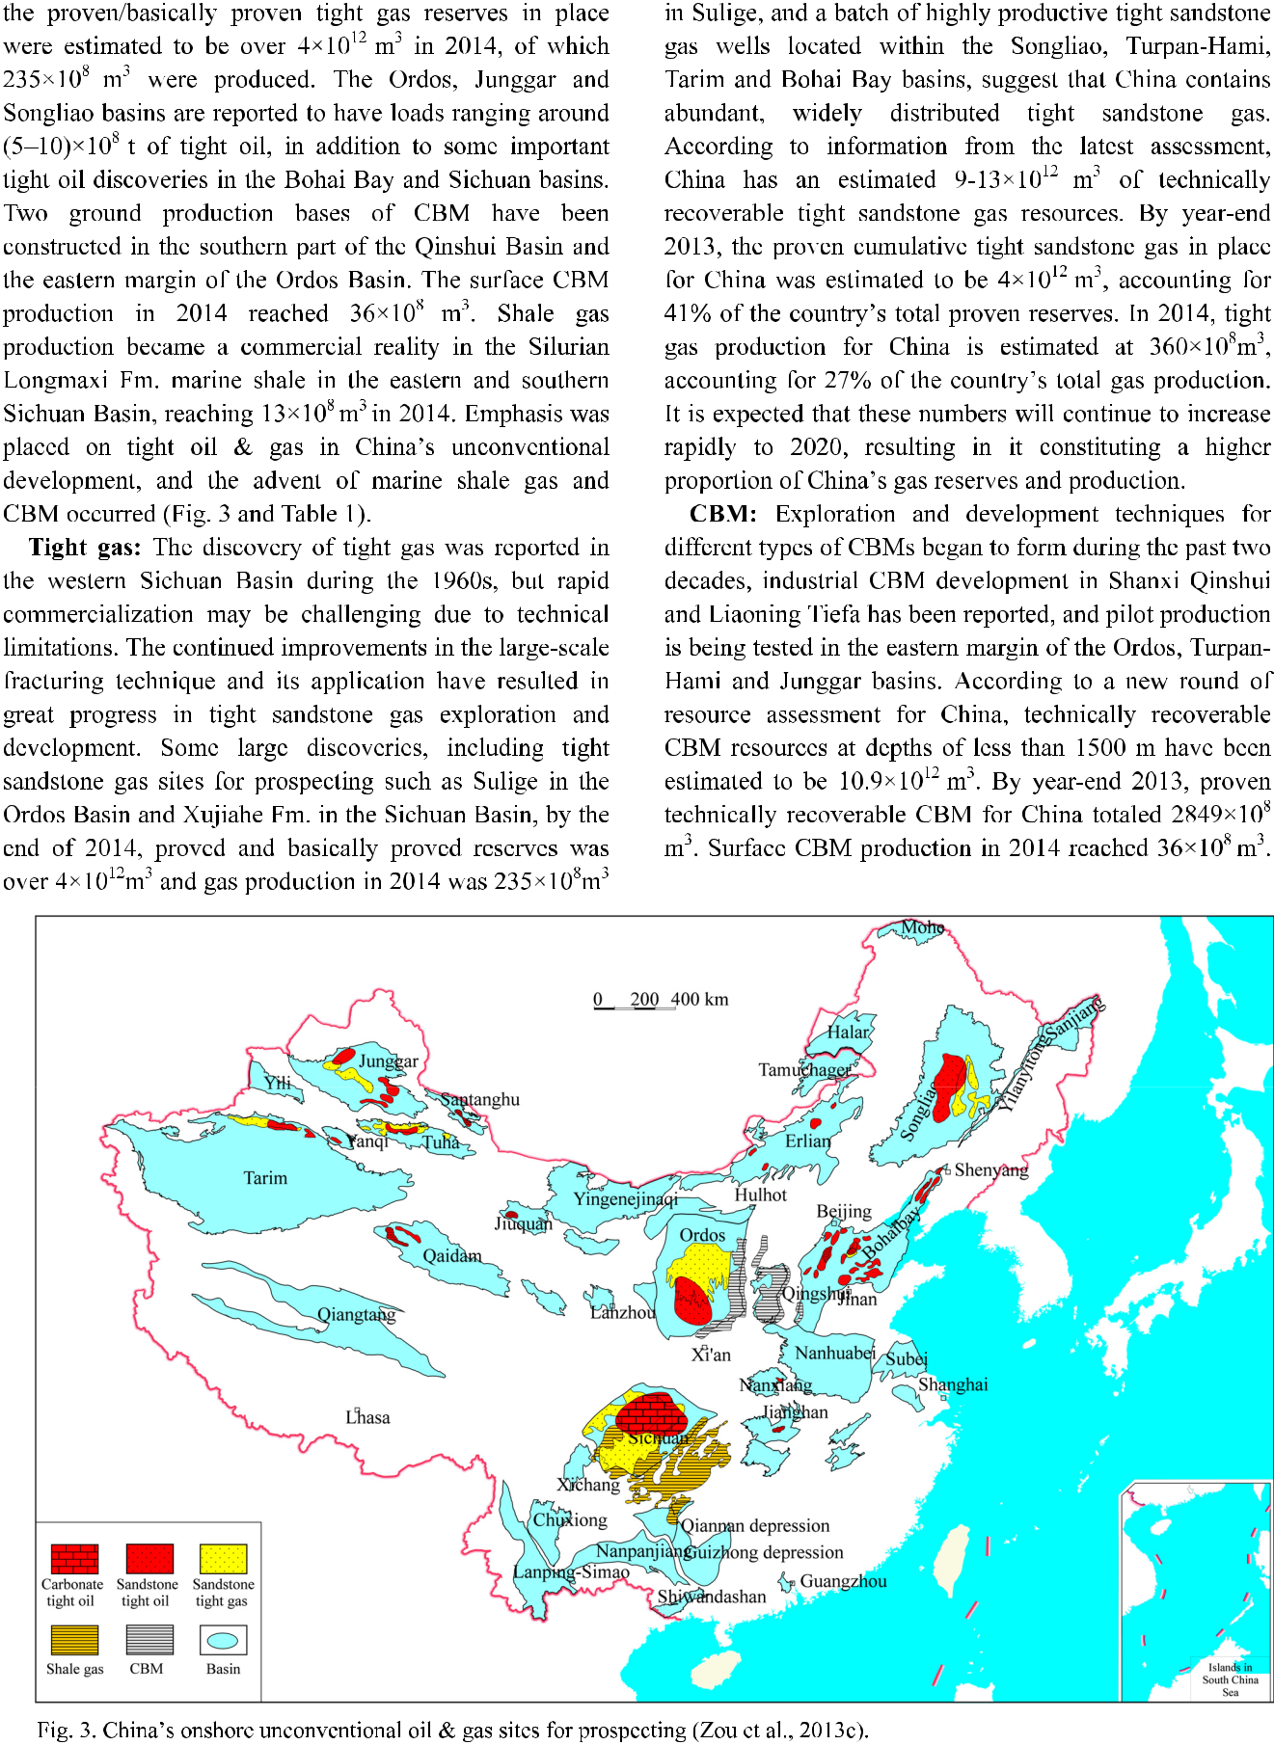

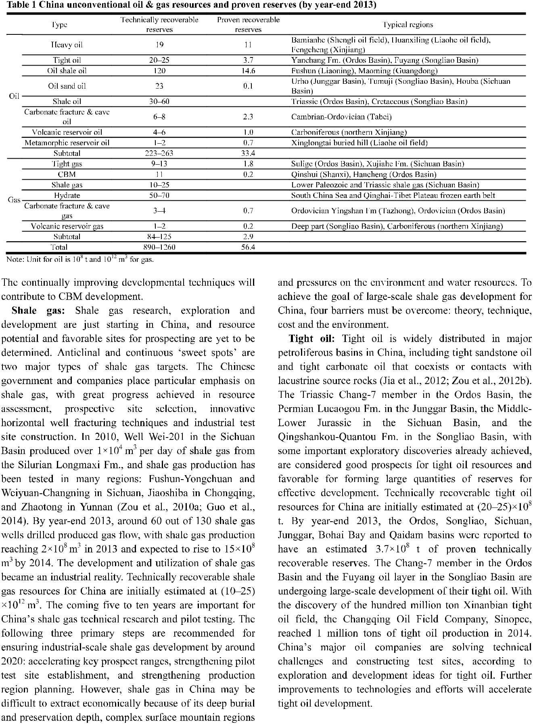

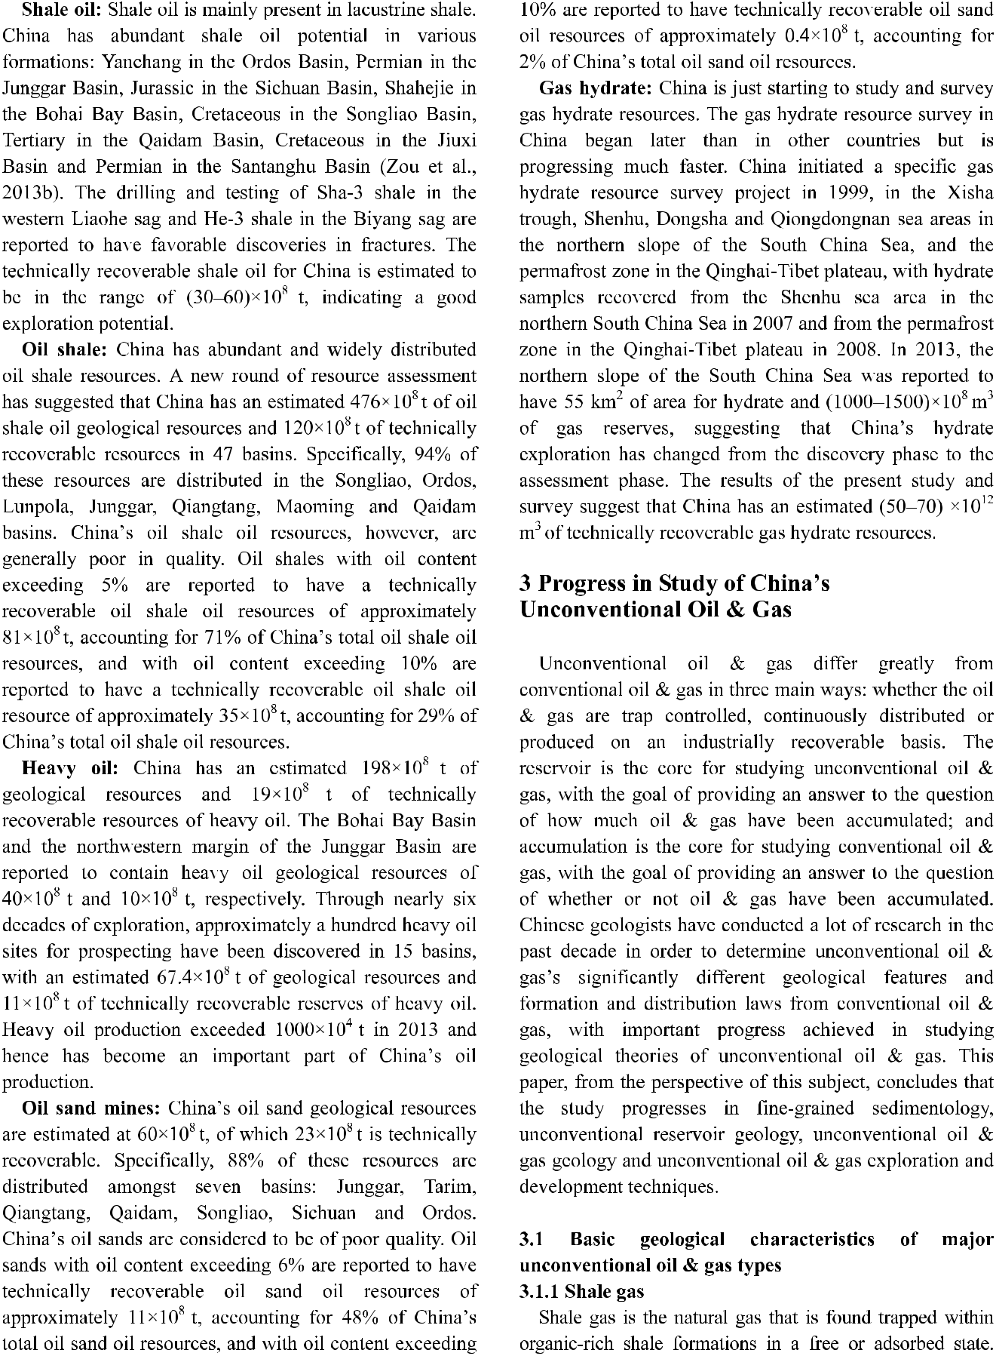

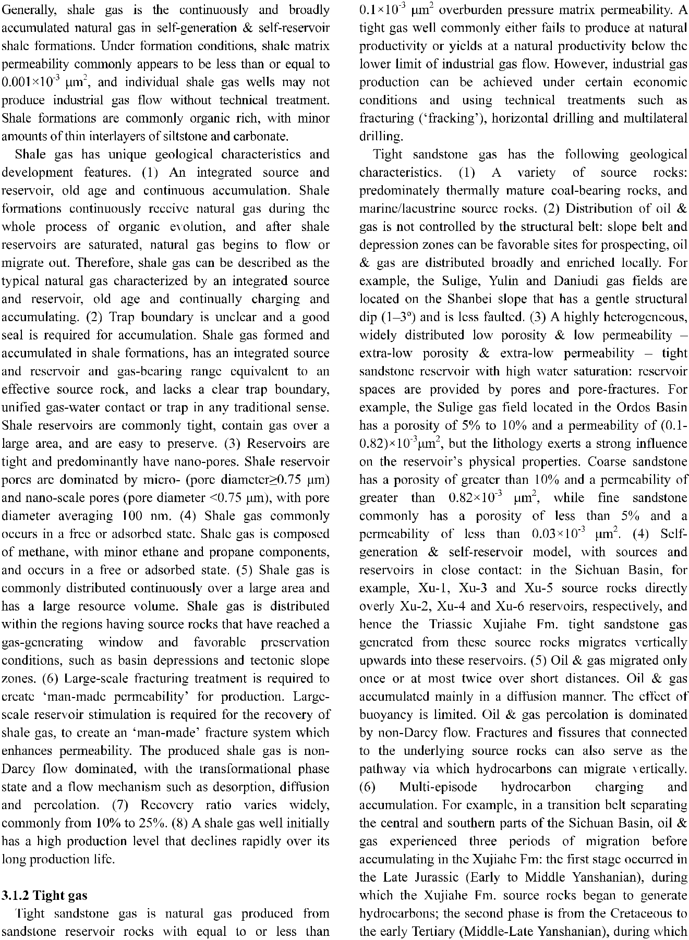

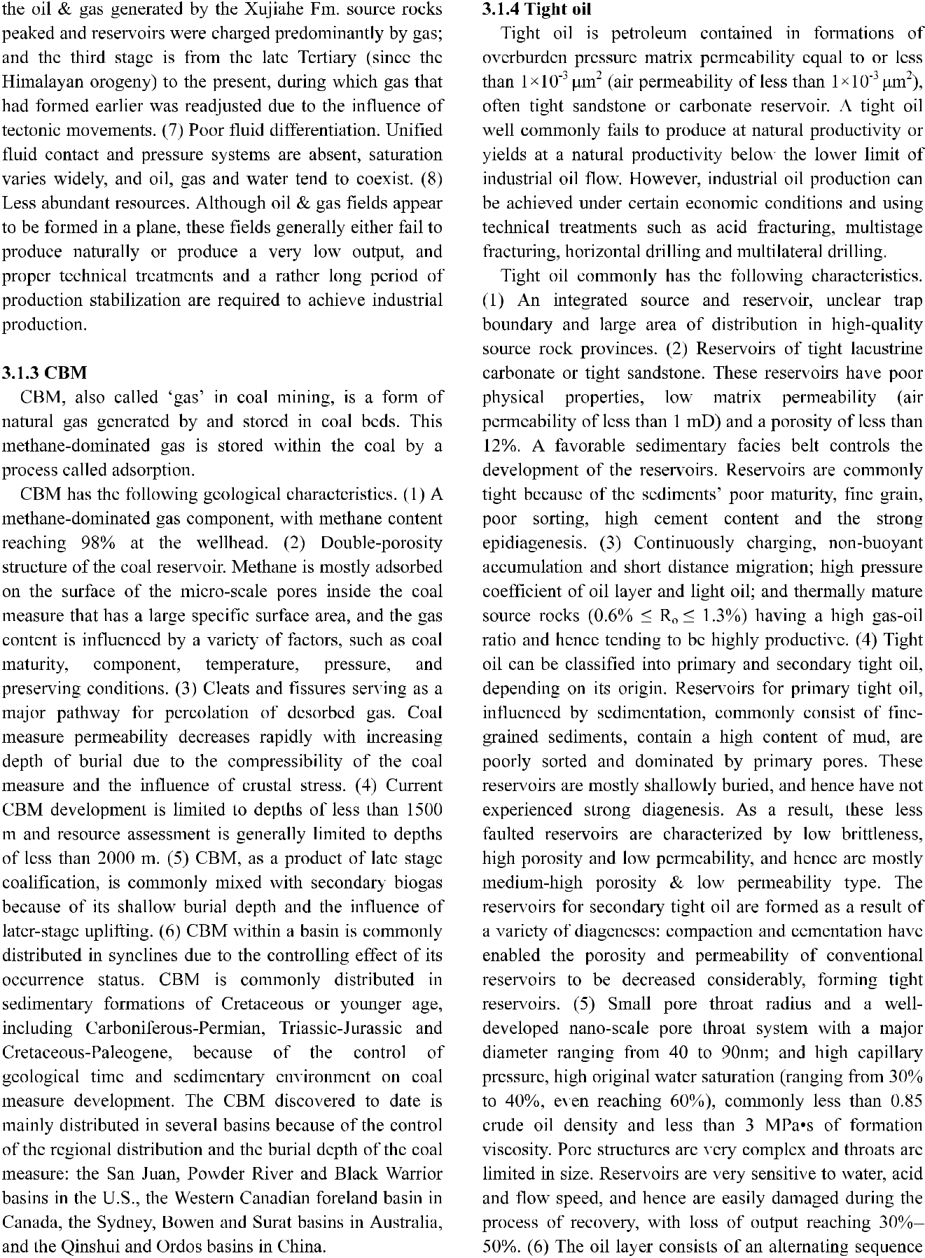

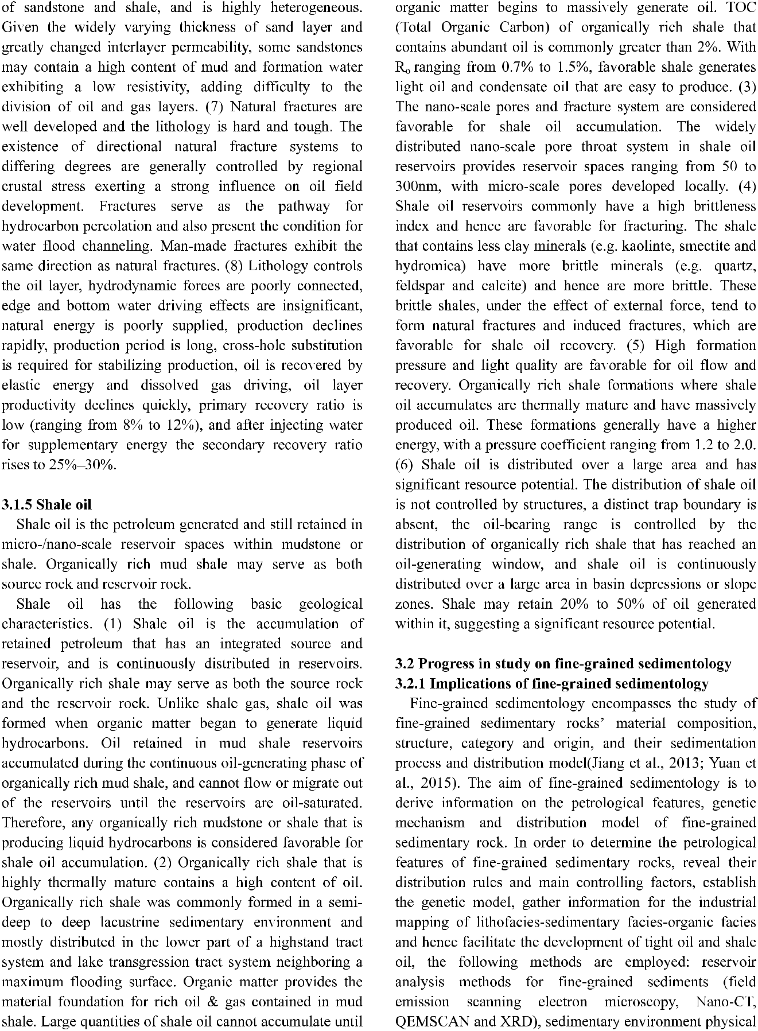

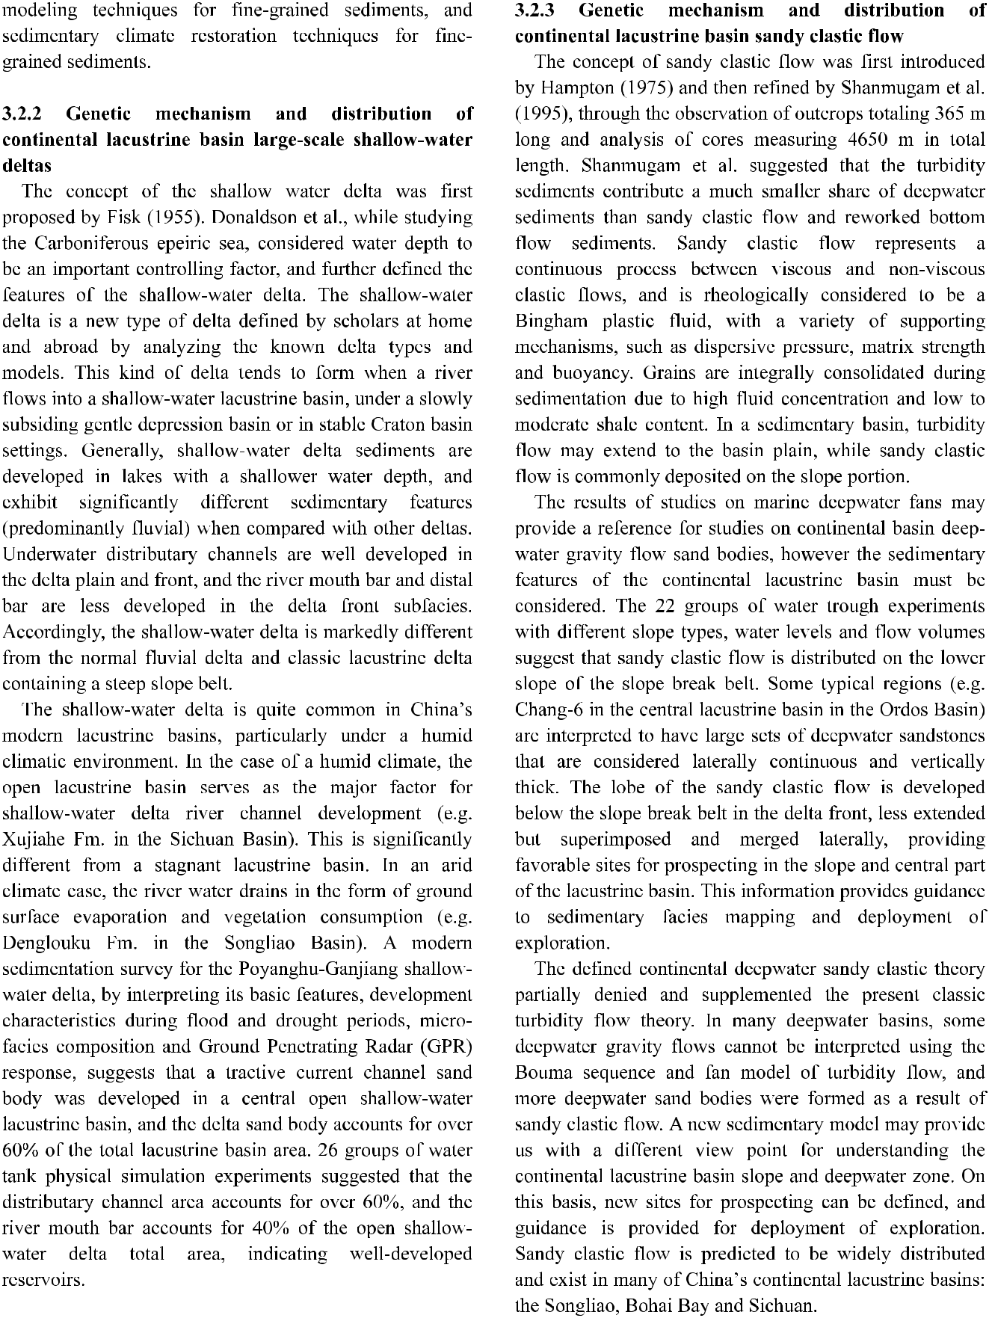

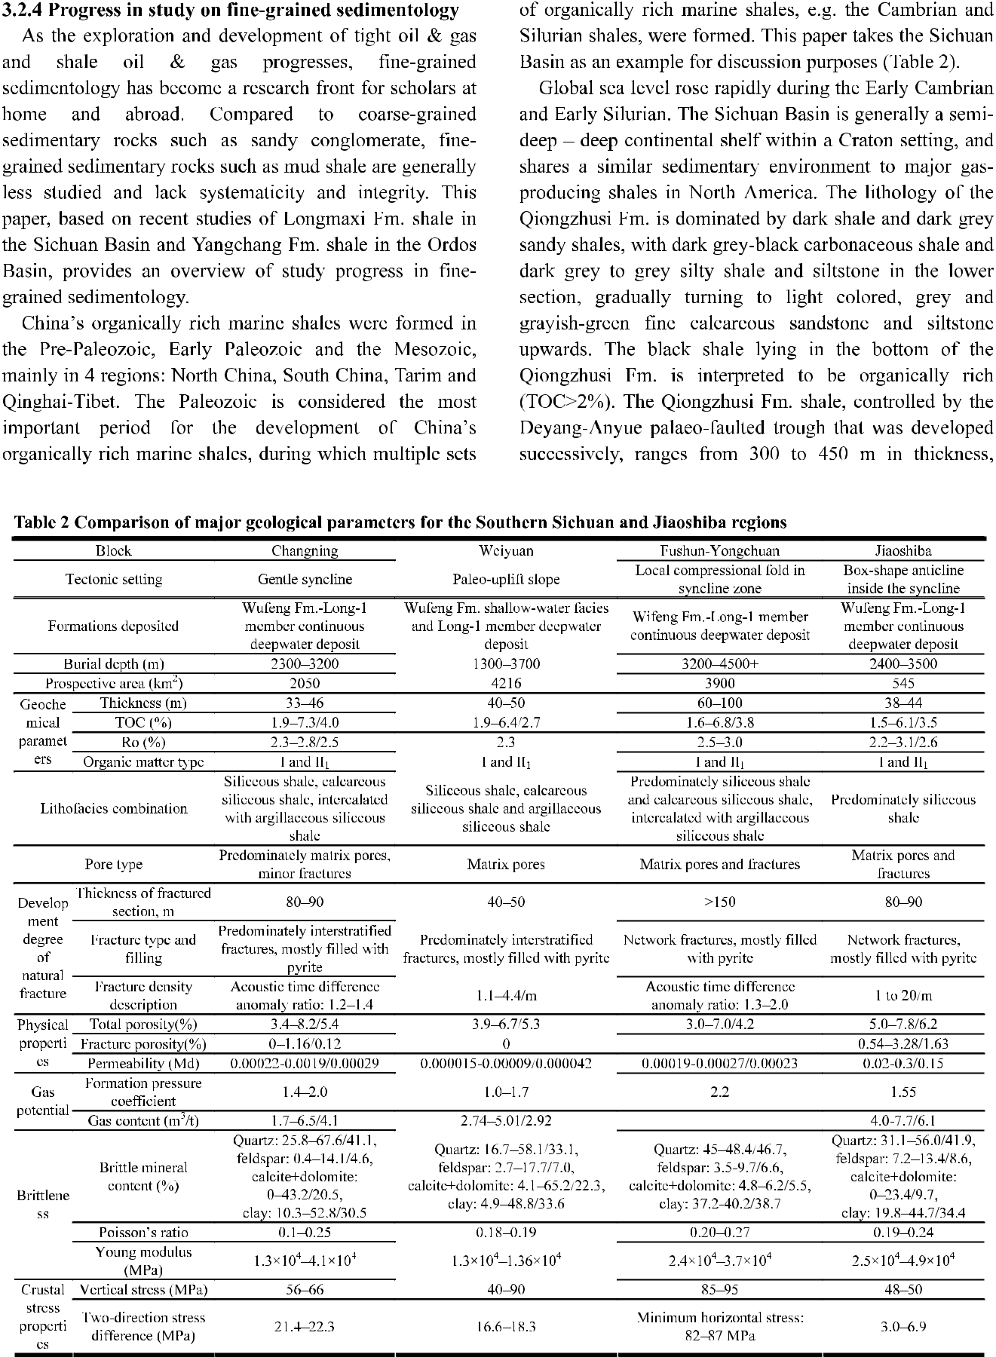

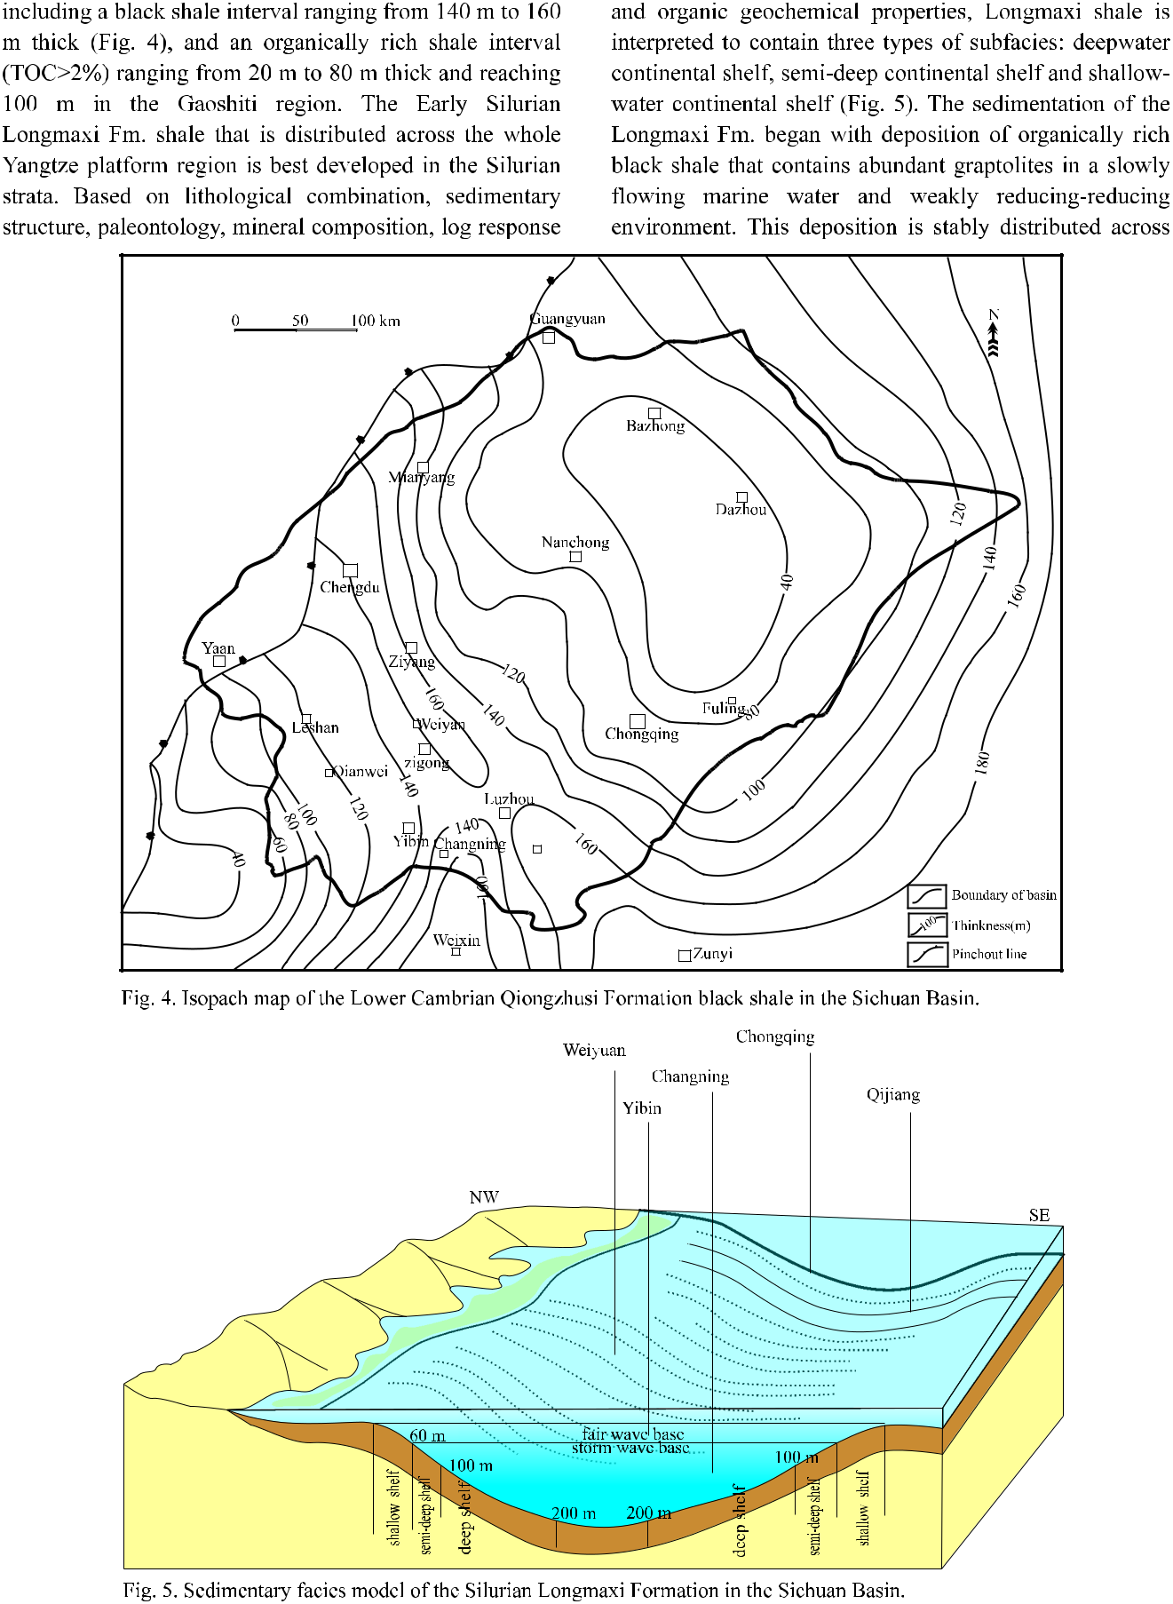

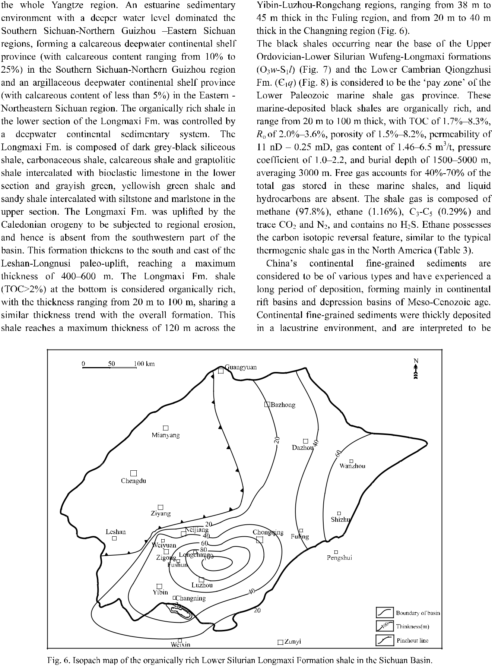

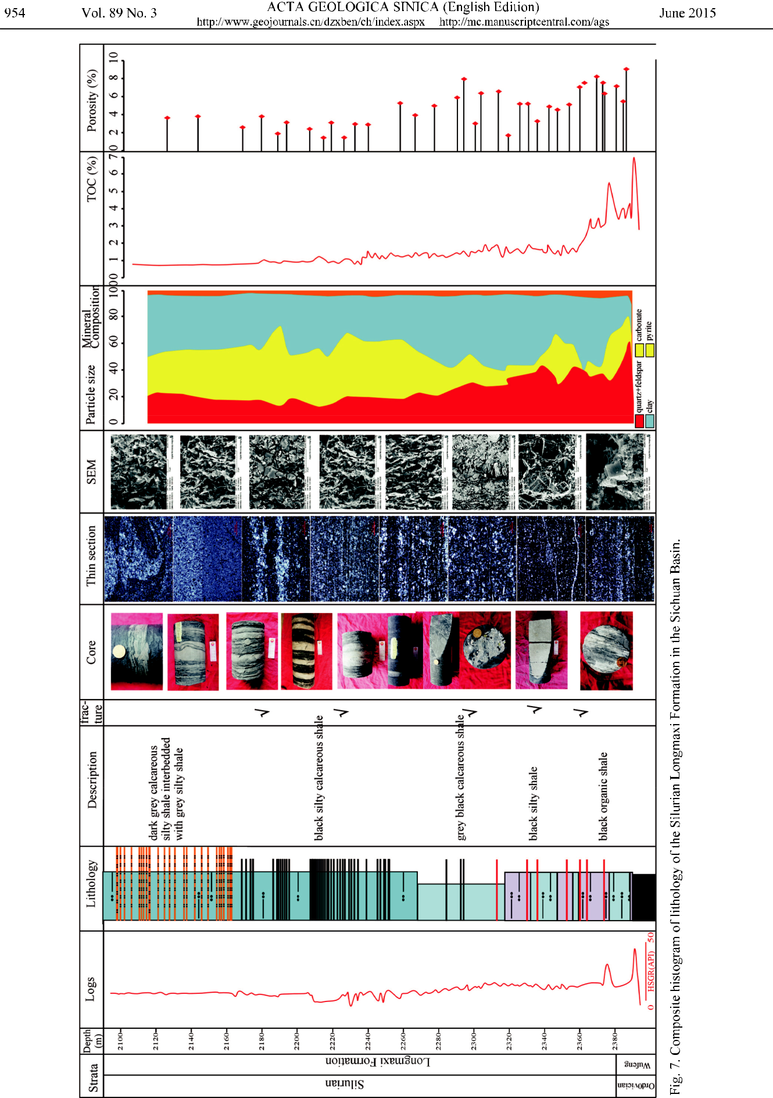

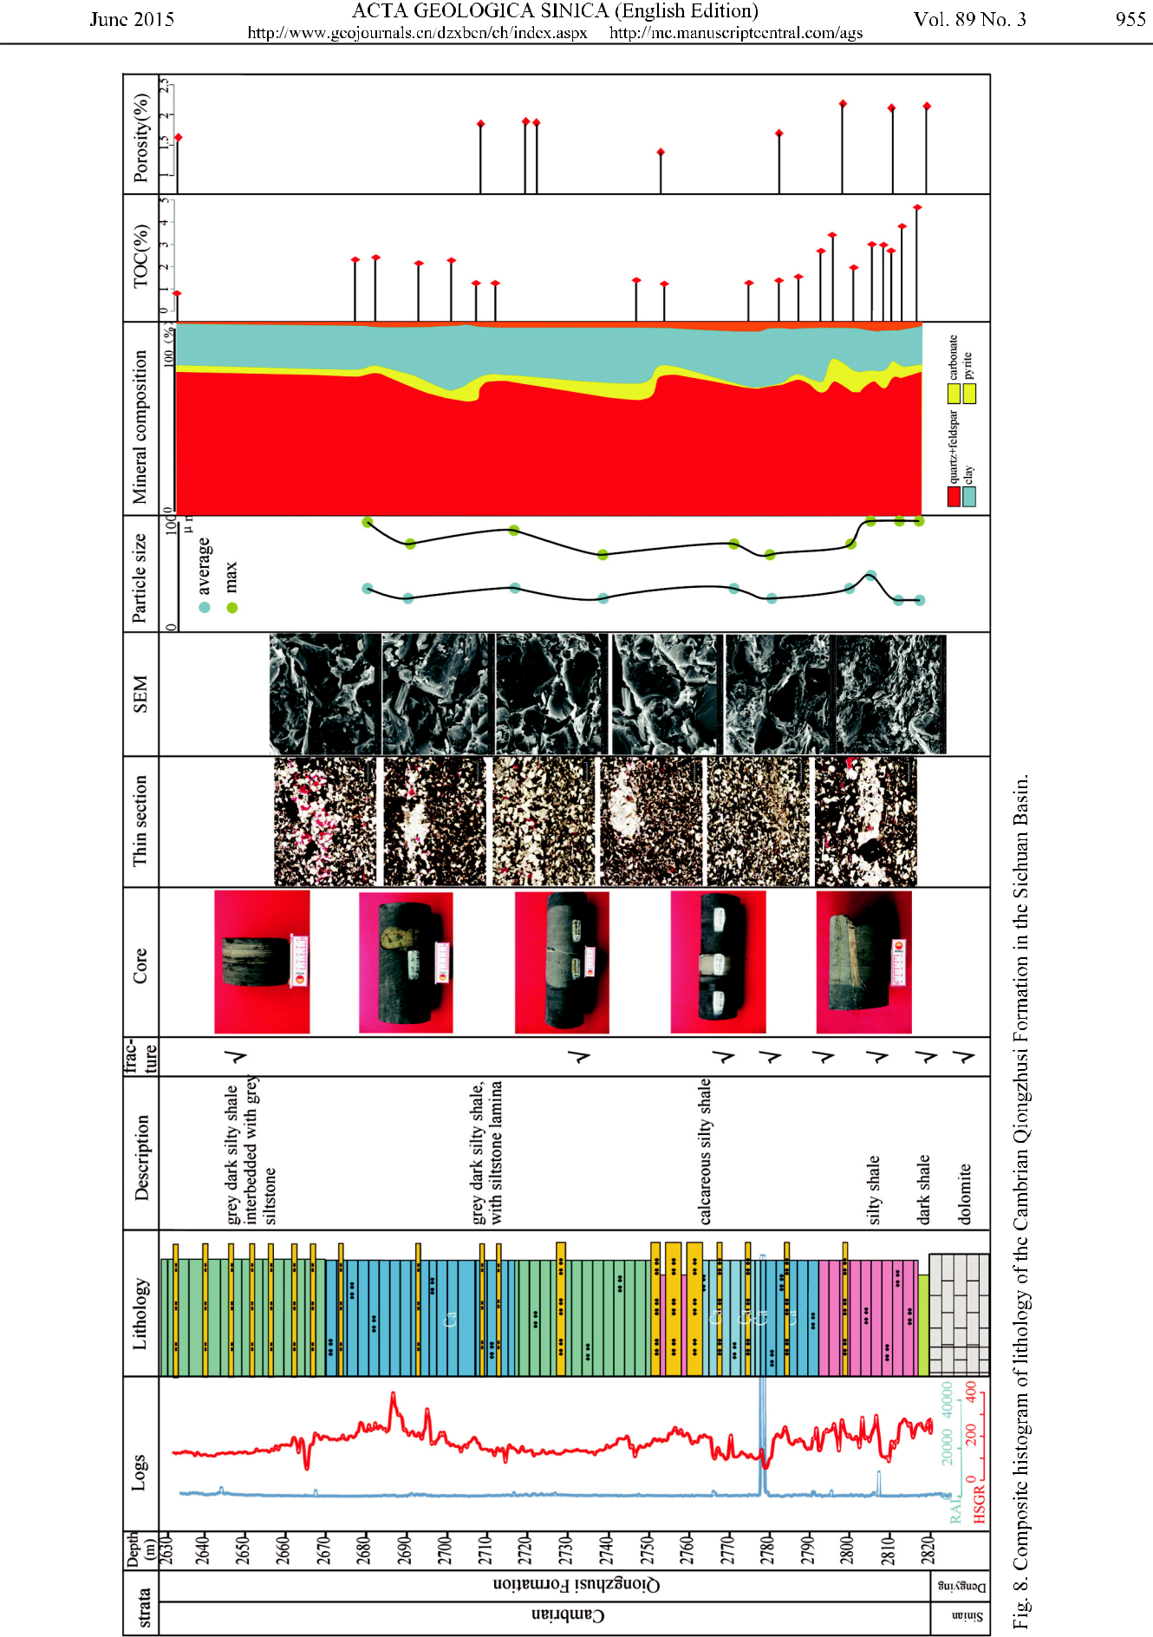

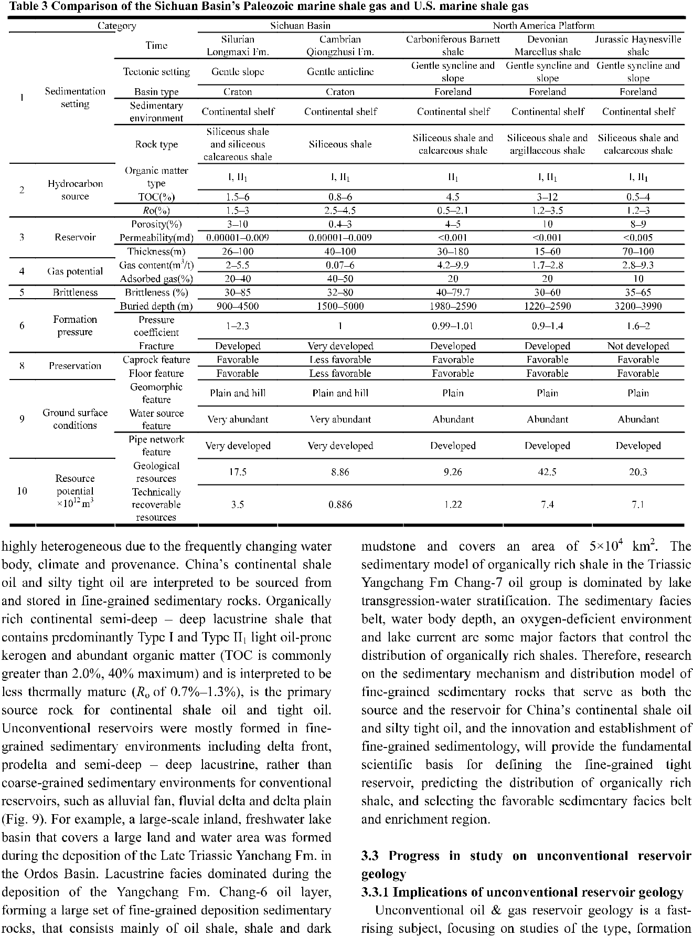



|  |  |  |
| --- | --- | --- |
| coarse | sediment |  |
|  |  |
| of |  |  |
| Area |  |  |

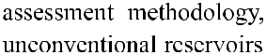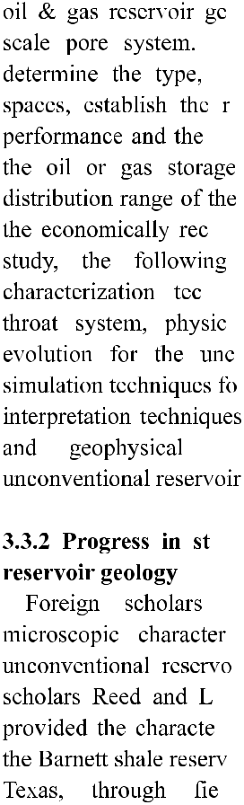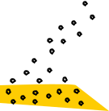

|  |  |  |
| --- | --- | --- |
|  | sediments |  |
| fine | grained |  |
|  |  |
| of |  |  |
| Area |  |  |

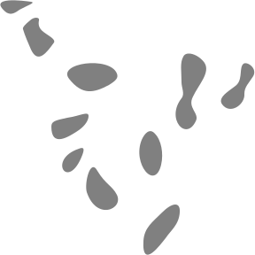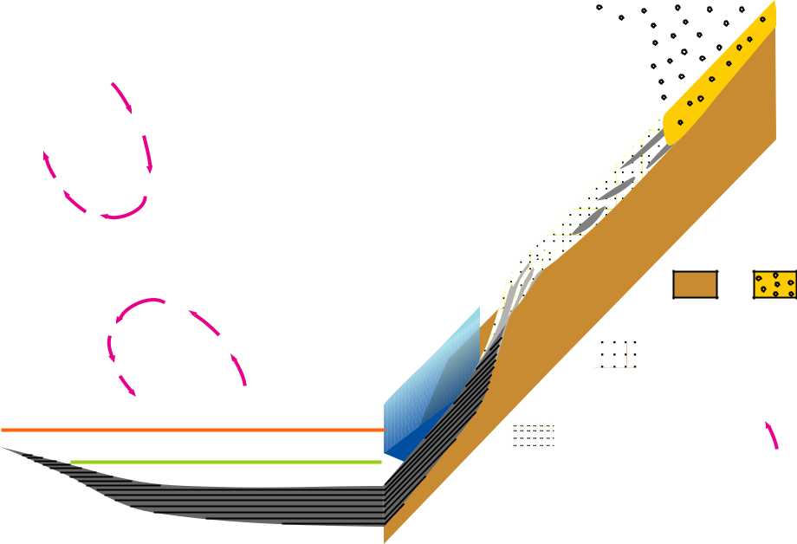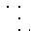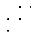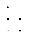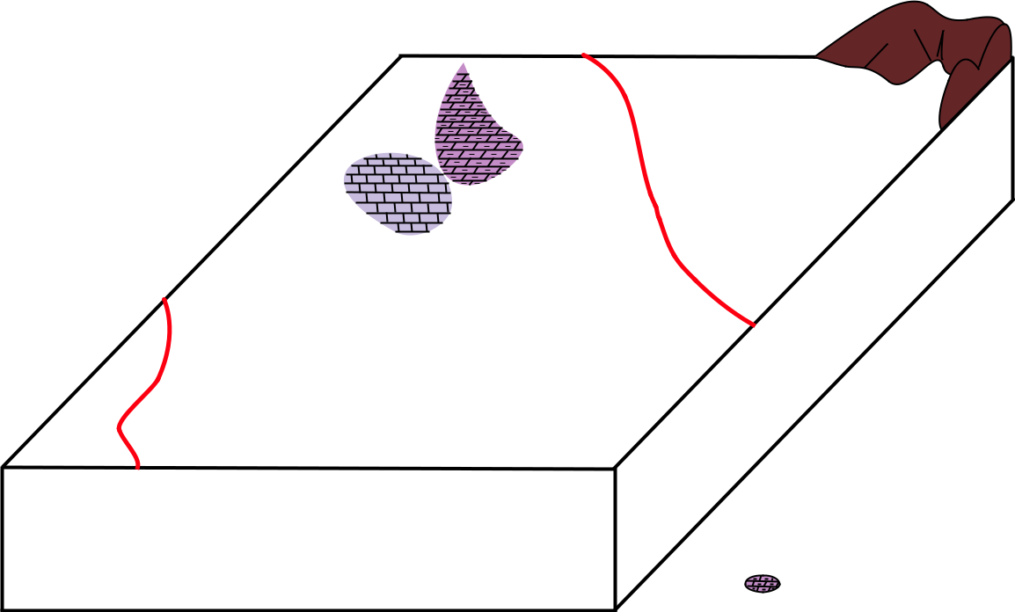

Shore shallow lake (aerobic zone)

Semi-deep lake (anoxic zone)

Deep lake (anaerobic zone)

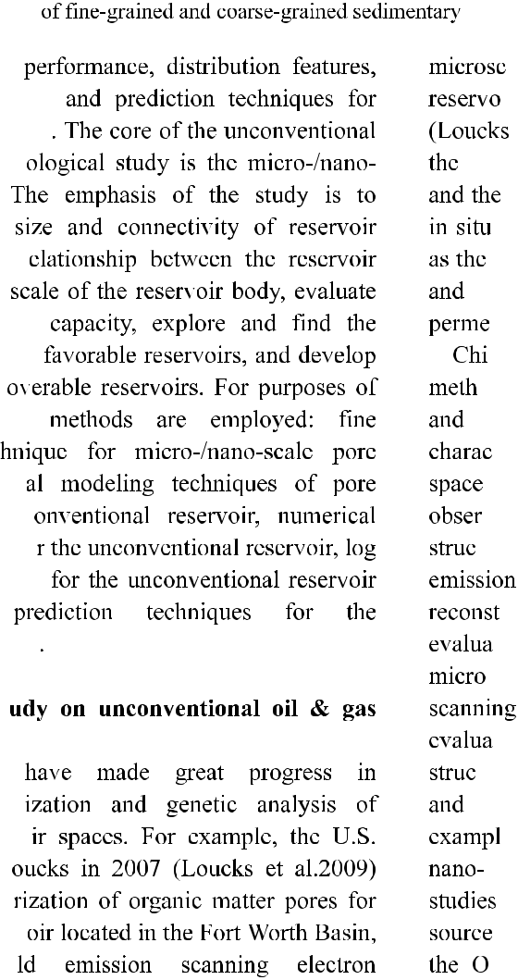

|  |  |  |
| --- | --- | --- |
| coarse | sediment |  |
|  |  |
| of |  |  |
| Area |  |  |

|  |  |  |  |  |  |  |  |  |  |  |  |  |  |  |  |  |  |  |  |  |  |
| --- | --- | --- | --- | --- | --- | --- | --- | --- | --- | --- | --- | --- | --- | --- | --- | --- | --- | --- | --- | --- | --- |
|  |  |  |  |  |  |  |  |  | Basement | | |  | Alluvial | | | | |  | Flood | |  |
|  |  |  |  |  |  |  |  |  |  |  |  |  |  | fan | | | |  | plan | |  |
|  |  |  |  |  |  |  |  |  |  |  |  |  |  |  |  |  |  |  |  |  |  |
|  |  |  |  |  |  |  |  |  |  |  |  |  |  |  |  |  |  |  |  |  |  |
|  |  |  |  |  |  | Channel | | | Deep lake | | |  |  | Shore |  | | |  | Delta | |  |
|  |  |  |  | sand bady | | | | | shallow lake front lobe | | | | | | | | |  |
|  |  |  |  |  |  |  |  |
|  |  |  |  |  |  |  |  |  |  |  |  |  |  |  |  |  |  |  |  |  |  |
|  |  |  |  |  |  |  |  |  |  |  |  |  |  |  |  |  |  |  |  |  |  |
| Sheet silt | | | | Sandy debirs | | | | |  | Turbidite | |  |  | lake | | | | Lacustrine | | |  |
|  |  |  |  | flow sand body sand body | | | | | | | | |  | currnt | | | | carbonate rock | | |  |
|  |  |  |  |  |  |  |  |  | |  |  |  |  |  |  |  |  |  |  |  |  |
| Lacustrine | | | |  |  | Silty Carbonaceous | | | | | |  |  | Organic | | | | Mountain | | |  |
| hybride rock mudstone | | | | | | | | | shale | | |  |  | shale | | | |  | range | |  |

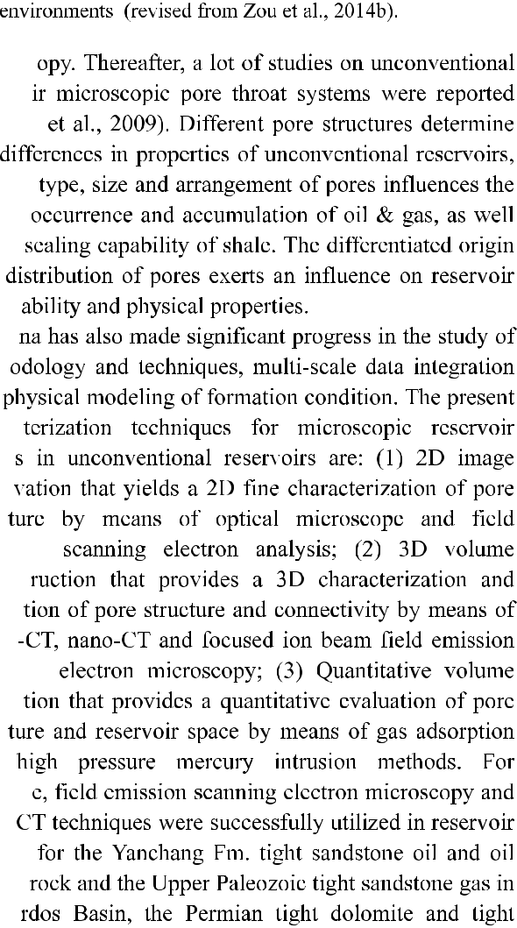



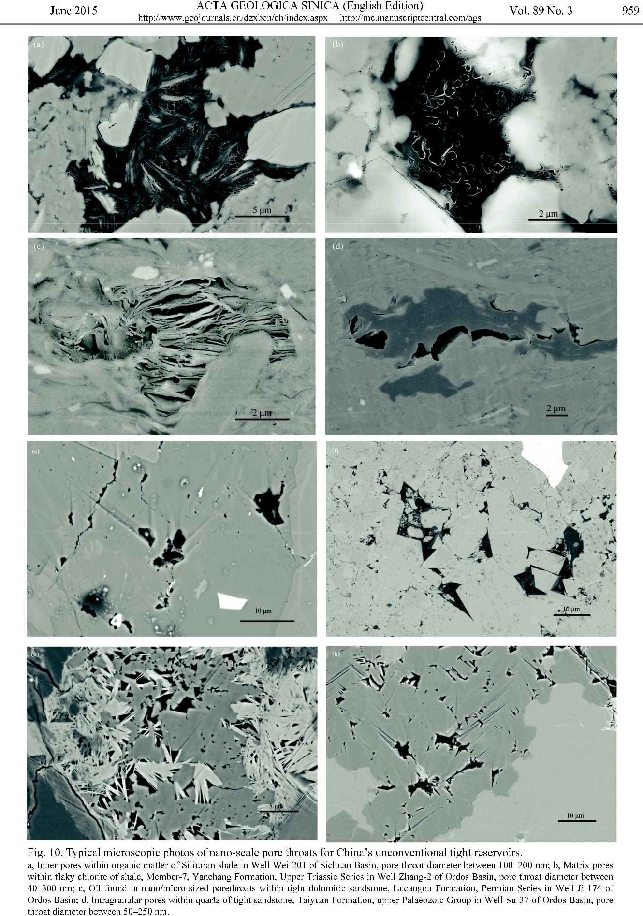

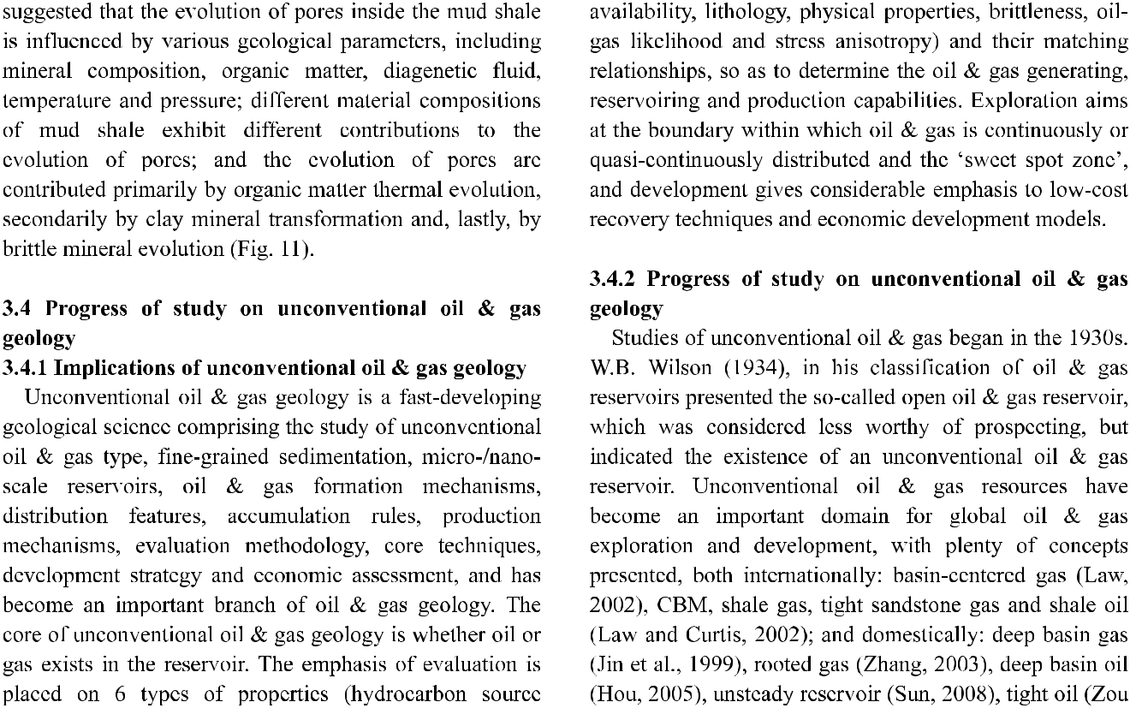

|  |  |  |  |  |  |  |  |  |  |  |  |  |  |  |  |  |  |  |  |  |  |  |  |  |  |  |  |  |  |  |  |  |  |  |  |  |  |  |  |  |  |  |  |  |  |  |  |  |  |  |  |  |  |  |  |
| --- | --- | --- | --- | --- | --- | --- | --- | --- | --- | --- | --- | --- | --- | --- | --- | --- | --- | --- | --- | --- | --- | --- | --- | --- | --- | --- | --- | --- | --- | --- | --- | --- | --- | --- | --- | --- | --- | --- | --- | --- | --- | --- | --- | --- | --- | --- | --- | --- | --- | --- | --- | --- | --- | --- | --- |
| Diagenesis | | | | Hydrocarbon | Modeling | | | | | | | |  |  |  |  |  | Ro | | | | |  | S1+S2 | |  | Clay mineral | | | | |  |  | 3D model |  |  |  | 2D imaging | | | | | | | | |  |  |  | Porosity | | |  |  |  |
|  | Phase | | | generation |  |  |  | temp. | | | | | (%) | | | | | |  |  |  |  |  | (mg/g) | |  |  |  |  |  |  |  |  |  |  |  |  |  | evolution | | | |  |  |  |
|  |  |  |  |  |  |  |  |  |  | (%) | | | |  |  |  |  |  |  |  |  |  |  |  |  |  |  |  |  |  |  |  |  |  |
|  |  |  |  |  |  |  |  |  |  |  |  |  |  |  |  |  |  |  |  |  |  |  |  |  |  |  |  |  |  |  |  |  |  |  |  |  |  |  |  |  |  |  |  |
|  |  |  |  |  |  |  |  |  |  |  |  |  |  |  |  |  |  |  |  |  |  |  |  |  |  |  |  |  |  |  |  |  |  |  |  |  |  |  |  |  |  |  |  |  |  |  |  |  |  |  |  |  |  |  |  |
|  |  |  |  |  |  |  |  |  |  |  |  |  |  | | | |  |  | |  |  | | **0** | 15.84 | |  | 45 |  |  |  |  | 55 | |  |  |  |  |  |  |  |  |  |  |  |  |  | 0 | % | | | |  | 2.5 | |  |
| Eodiagenesis |  |  |  |  |  |  |  |  |  |  |  |  |  |  |  |  |  |  |  |  |  |  |  |  |  |  |  |  |  |  |  |  |  |  |  |  |  |  |  |  |  |  |  |  |  |  | 0 |  | cm3 /g | | | | 0.04 | |  |
|  |  |  |  |  |  |  |  |  |  |  |  |  |  |  |  |  |  |  |  |  |  |  |  |  |  |  |  |  |  |  |  |  |  |  |  |  |  |  |  |  |  |  |  |  |  |  |  |
|  | A | |  |  |  |  | ?oC | | | | | 0.35 | | | | | | | |  |  |  |  |  |  |  |  |  |  |  |  |  |  |  |  |  |  |  |  |  |  |  |  |  |  |  |  |  |  |  |  |  |  |  |
|  |  |  |  |  |  |  |  |  |  |  |  |  |  |  |  |  |  |  |  |  |  |  |  |  |  |  |  |  |  |  |  |  |  |  |  |  |  |  |  |  |  |  |  |  |  |  |  |  |  |  |  |  |  |
|  |  |  |  |  |  |  |  |  |  |  |  |  |  |  |  |  |  |  |  |  |  |  |  |  |  |  |  |  |  |  |  |  |  |  |  |  |  |  |  |  |  |  |  |  |  |  |  | ? | | | |  |  |  |  |
|  |  |  |  |  |  |  |  |  |  |  |  |  |  |  |  |  |  |  |  |  |  |  |  |  |  |  |  |  |  |  |  |  |  |  |  |  |  |  |  |  |  |  |  |  |  |  |  |  |  |  |  |
|  |  | B | |  |  |  |  |  |  |  |  |  |  |  |  |  |  |  |  |  |  |  |  | ? ? |  |  | ? ? | | | | |  |  |  |  |  |  |  |  |  |  |  |  |  |  |  |  |  |  |  |  |  |  |  |  |
|  |  |  |  |  |  |  |  | ?oC | |  | |  |  | | | | 0.5 | |  |  |  |  |  |  |  |  |  |  |  |  |  |  |  |  |  |  |  |  |  |  |  |  |  |  |  |  |  |  |  |  |  |  |  |  |  |
|  |  |  |  |  |  |  |  | |  |  | | | |  |  |  |  |  |  |  |  |  |  |  |  |  |  |  |  |  |  |  |  |  |  |  |  |  |  |  |  |  |  |  |  |  |  |  |  |  |
| Mesodiagenesis |  | A | |  |  |  |  | 200oC |  |  |  |  |  |  |  | 0.7 | | |  |  |  |  |  |  |  |  |  |  |  |  |  |  |  | 30 ìm | |  |  |  |  | 30 ìm | | | | | | |  |  |  |  |  |  |  |  |  |
|  |  |  |  |  |  |  |  |  |  |  |  |  |  |  |  |  |  |  |  |  |  |  |  |  |  |  |  |  |  |  |  |  |  |  |  |  |  |  |  |
|  |  |  |  |  |  |  |  |  |  |  |  |  |  |  |  |  |  |  |  |  |  |  |  |  |  |  |  |  |  |  |  |  |  |  |  |  |  |  |  |  |  |  |  |
|  |  |  |  |  |  |  |  | 350oC | | | |  |  | 1.2 | | | | |  |  |  |  |  |  |  |  |  |  |  |  |  |  |  |  |  |  |  |  |  |  |  |  |  |  |  |  |  |  |  |  |  |  |  |
|  |  |  |  |  |  |  |  |  |  |  |  |  |  |  |  |  |  |  |  |  |  |  |  |  |  |  |  |  |  |  |  |  |  |  |  |  |  |  |  |  |  |  |  |  |  |  |
|  |  |  |  |  |  |  |  |  |  |  |  |  |  |  |  |  |  |  |  |  |  |  |  |  | 30 | ìm |  |  |  |  |  | 30 ìm | | | | | |  |  |  |  |  |  |  |  |  |
|  |  |  |  |  |  |  |  |  |  |  |  |  |  |  |  |  |  |  |  |  |  |  |  |  |  |  |  |  |  |  |  |  |  |  |  |  |  |  |
|  |  |  |  |  |  |  |  |  |  |  |  |  |  |  |  |  |  |  |  |  |  |  |  |  |  |  |  |  |  |  |  |  |  |  |  |  |  |  |
|  |  |  |  |  |  |  |  |  |  |  |  |  |  |  |  |  |  |  |  |  |  |  |  |  |  |  |  |  |  |  |  |  |  |  |  |  |  |  |  |  |  |  |  |  |  |  |  |
|  |  | B | |  |  |  |  | 450oC | | | |  |  | 2.0 | | | | |  |  |  |  |  |  |  |  |  |  |  |  |  |  |  |  |  |  |  |  |  |  |  |  |  |  |  |  |  |  |  |  |  |  |  |
|  |  |  |  |  |  |  |  |  |  |  |  |  |  |  |  |  |  |  |  |  |  |  |  |  |  |  |  |  |  |  |  |  |  |  |  |  |  |  |  |  |  |  |  |  |
|  |  |  |  |  |  |  |  |  |  |  |  |  |  |  |  |  |  |  |  |  |  |  | 30 | ìm |  |  |  |  |  | 30 ìm | | | | | |  |  |  |  |  |  |  |  |  |
|  |  |  |  |  |  |  |  |  |  |  |  |  |  |  |  |  |  |  |  |  |  |  |  |  |  |  |  |  |  |  |  |  |  |  |  |  |  |  |
|  |  |  |  |  |  |  |  |  |  |  |  |  |  |  |  |  |  |  |  |  |  |  |  |  |  |  |  |  |  |  |  |  |  |  |  |  |  |  |
|  |  |  |  |  |  |  |  |  |  |  |  |  |  |  |  |  |  |  |  |  |  |  |  |  |  |  |  |  |  |  |  |  |  |  |  |  |  |  |  |  |  |  |  |  |  |  |  |
|  | Telodiagenesis | | |  |  |  |  | 550oC | | |  |  |  |  | 2.5 | | | |  |  |  |  |  |  |  |  |  |  |  |  |  |  |  |  |  |  |  |  |  |  |  |  |  |  |  |  |  |  |  |  |  |  |  |
|  |  |  |  |  |  |  |  |  |  |  |  |  |  |  |  |  |  |  |  |  |  |  |  |  |  |  |  |  |  |  |  |  |  |  |  |  |  |  |  | | | |  |  |  |
|  |  |  |  |  |  |  |  |  |  |  |  |  |  |  |  |  |  |  |  |  |  |  |  |  |  |  |  |  |  |  |  |  |  |  |  |  |  |  | Porosity | | | |  |  |  |
|  |  |  |  |  |  |  |  |  |  |  |  |  |  |  |  |  |  |  |  |  |  |  |  |  |  |  |  |  |  |  | 30 ìm | | | | | |  |  |  |  |  |
|  |  |  |  |  |  |  |  |  |  |  |  |  |  |  |  |  |  |  |  |  |  |  |  |  |  |  | 30 ìm | |  |  |  |  |  |  |  |  |  |  |  |  |  |  |
|  |  |  |  |  |  |  |  |  |  | |  |  |  |  |  |  |  |  |  |  |  |  |  |  |  |  |  |  |  |  |  |  |  |  |  |  |  |
|  |  |  |  |  |  |  |  |  |  |  |  |  |  |  |  |  |  |  |  |  |  |  |  |  |  |  |  |  |  |  |  |  |  |  |  |  |  |  |  |  |  |  |  |  |  |  |  |
|  |  |  |  |  |  |  |  |  |  |  |  |  |  |  |  |  |  |  |  |  |  |  |  |  |  |  |  |  |  |  |  |  |  |  |  |  |  |  |  |  |  |  |  |  |  |  | Pore volume | | | |  |  |  |
|  |  |  |  |  |  |  |  |  |  |  |  |  |  |  |  |  |  |  |  |  |  |  |  |  |  |  |  |  |  |  |  |  |  |  |  |  |  |  |  |  |  |  |  |  |  |  |  |  |  |  |  |
|  |  |  |  |  |  |  |  |  |  |  |  |  |  |  |  |  |  |  |  |  |  |  |  |  |  |  |  |  |  |  |  |  |  |  |  |  |  |  |  |  |  |  |  |  |  |  |  |  |  |  |  |  |  |  |  |
|  |  |  |  |  |  |  |  |  |  |  |  |  |  |  |  |  |  |  |  |  |  |  |  |  |  |  |  |  |  |  |  |  |  |  |  |  |  |  |  |  |  |  |  |  |  |  |  |  |  |  |  |  |  |  |  |
|  |  |  |  |  |  |  |  |  |  |  |  |  |  |  |  |  |  |  |  |  |  |  |  |  |  |  |  |  |  |  |  |  |  |  |  |  |  |  |  |  |  |  |  |  |  |  |  |  |  |  |  |  |  |  |  |

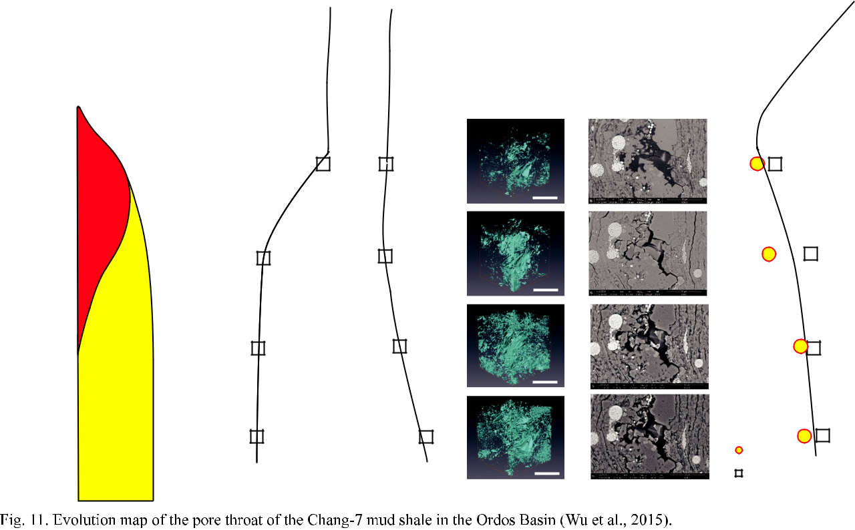



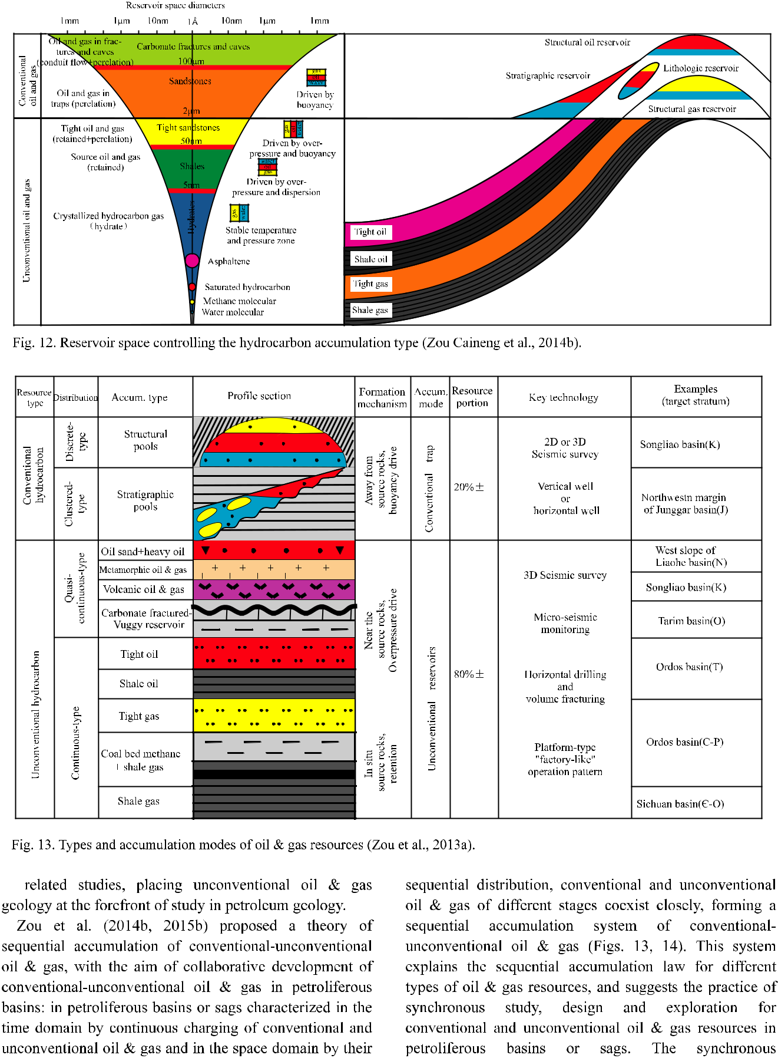

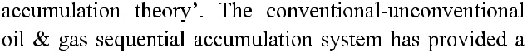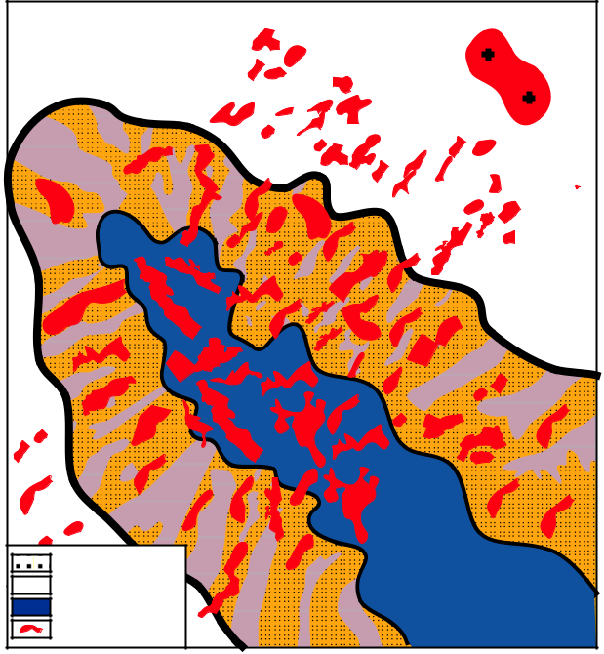

|  |  |  |  |
| --- | --- | --- | --- |
| ~~Li~~tholo~~gic~~ | Structural | r~~eser~~voir |  |
| reservoir |  |
|  |  |  |
| Tight |  |  |  |
| oil |  |  |  |
| Shale |  |  |  |
| oil |  |  |  |

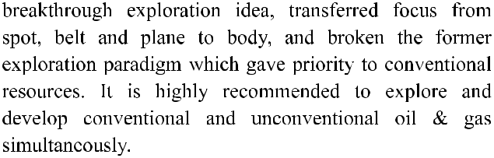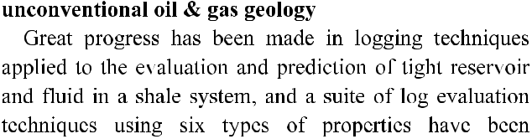

Sandstone



 Mudstone

Shale developed



area

Hydrocarbon

accumulation

